**Export Employee data from HDFS to MySQL– SQOOP**

**MapReduce**

Sqoop is a command-line interface application for transferring data between relational databases and Hadoop.

**Pros**

* It involves transferring data from a variety of structured sources of data like Oracle, Postgres, etc.
* The data transfer is in parallel, making it fast and cost-effective.
* A lot of processes can be automated, bringing in heightened efficiency.
* It is possible to integrate with Kerberos security authentication.

**Input Directory**

Input directory contains input table that will be uploaded to Sqoop.



In the above screenshot, we can see an input directory (employee_data) contains input file – employee_data.

**Input_table**

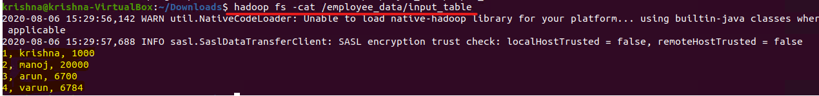

In the above screenshot, we can see that input contains employee_id, Name & Salary data.

**Create Database employeedb**



In the above screenshot, we can see the employeedb is created.

**Create Table employee**



In the above screenshot, we can see the schema of the employee table.

**Command to export data from hdfs to mysql**

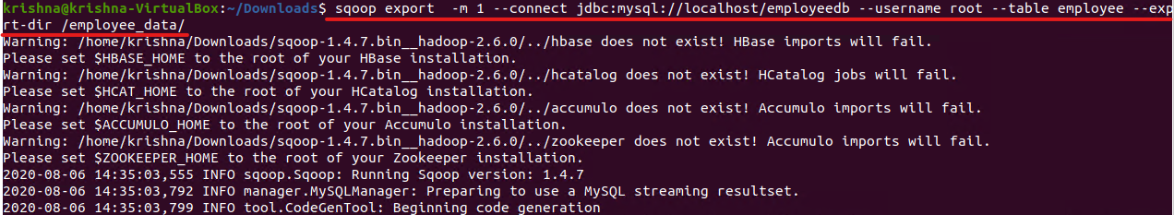

**sqoop export -** export to sqoop

**-m 1 -** number of mapper run 1

**Jdbc:mysql://localhost/employeedb –** Connection to the database employeedb

**--username –** mysql username to verify that user has write access or not

**--table –** mysql table name

**--export-dir –** where data have to pick to insert into mysql

**Sqoop Command Output**

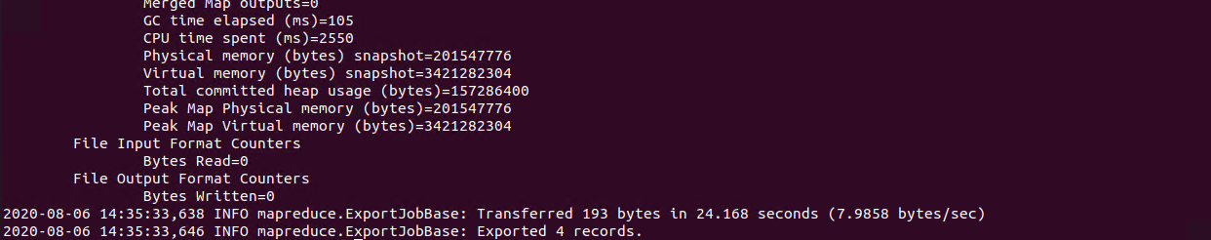

In the above screenshot, we can see that 4 records are exported from hdfs to mysql.

**Verify data in MySQL**

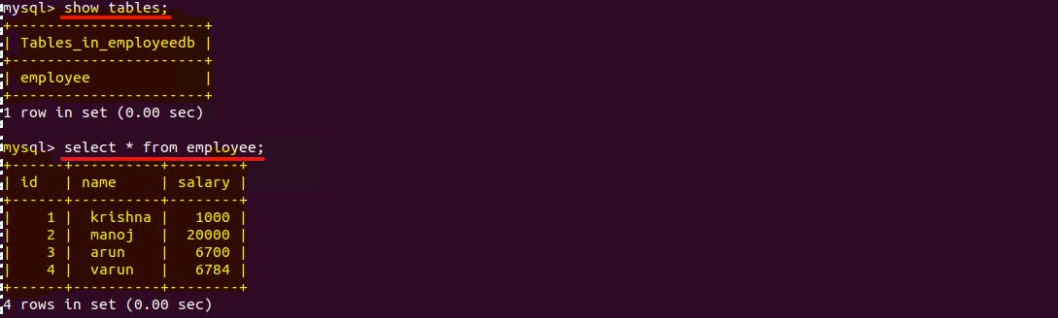

In the above screenshot, we can see that employee table contains all 4 rows.

**Some Basic Operations:**

1. **Count records in employee table**

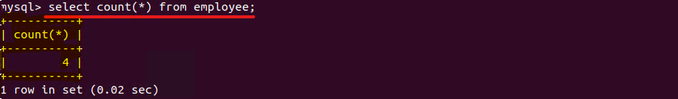

In the above screenshot, we can see that count is 4.

1. **Select top 2 rows**

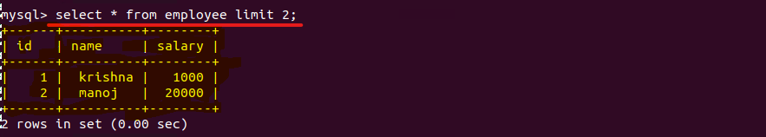

In the above screenshot, top 2 records are printed on the screen.